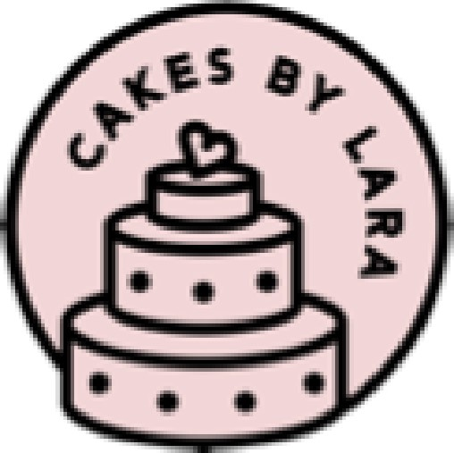
Flavours
Chocolate Cake filled with Chocolate ganache.
Chocolate sponge filled with rich and creamy chocolate ganache.
Classic Victoria sponge
Sandwiched with "Little Pod" vanilla buttercream and strawberry jam or a seasonal handmade fruit compote.
Coffee and Toasted Walnut Cake
Moist coffee cake sandwiched with coffee buttercream, decorated with crushed toasted walnuts (optional)
Lemon drizzle cake with Elderflower buttercream or Lemon Buttercream
Moist lemon cake with a lemon syrup filled with an elderflower buttercream
Chocolate Orange Cake – Chocolate sponge with a hint of orange zest filled with Terrys Chocolate Orange
Specialty Flavour
Carrot Cake
Moist carrot cake sandwiched with a cinnamon cream cheese frosting or vanilla buttercream
Raspberry and White Chocolate cake
Vanilla sponge filled with raspberry coulis and white chocolate ganache.
Chocolate Salted Caramel Cake
Moist chocolate cake sandwiched and drizzled with homemade salted caramel buttercream.
Lemon and Poppy seed cake with Limoncello Buttercream
Moist lemon sponge made with Limoncello, drizzled with a lemon syrup then filled with Lemon buttercream. (Lemons can be substituted for the limoncello)

Red Velvet Cake
Moist chocolate sponge with a hint of red, covered and filled with cream cheese frosting or vanilla buttercream.
*Gluten and Dairy free variations are available, please be aware that *
Nuts, Dairy and Gluten are used in the kitchen.

Prices
Celebration Cakes
5" 4 layer serves approx. 14 - £58.
4 layer serves approx. 25 - £68.
7” 4 layer serves approx. 45 - £78
*Larger sizes available*
Specialty celebration Cakes
5" 4 layer serves approx. 14 - £62.
4 layer serves approx. 25 - £72.
7” 4 layer serves approx. 45 - £82
*Larger sizes available*
*Prices above are for the cake itself with a simple buttercream decoration and a personalised message on the board. Toppers and extra decorating will be extra, prices confirmed after design has been decided*
* Fondant covered theme cakes will be priced accordingly to the size and design*
Bespoke handmade figures - £30 each
Cupcake Prices (minimum order 6)
Cupcakes with handmade bespoke toppers - £3.00 ea.
Cupcakes with buttercream swirl - £2.50 ea.

Chocolate Salted Caramel Brownies
Box of 6 - £16.50
Box 12 - £30.00

